Send Mail With SMTP server

1.For setup SMTP sever login (http://app.sendinblue.com/marketing-campaign/list) this server give your phone number and Email Id,OTP.

1. After completion of sign in we can see blow page

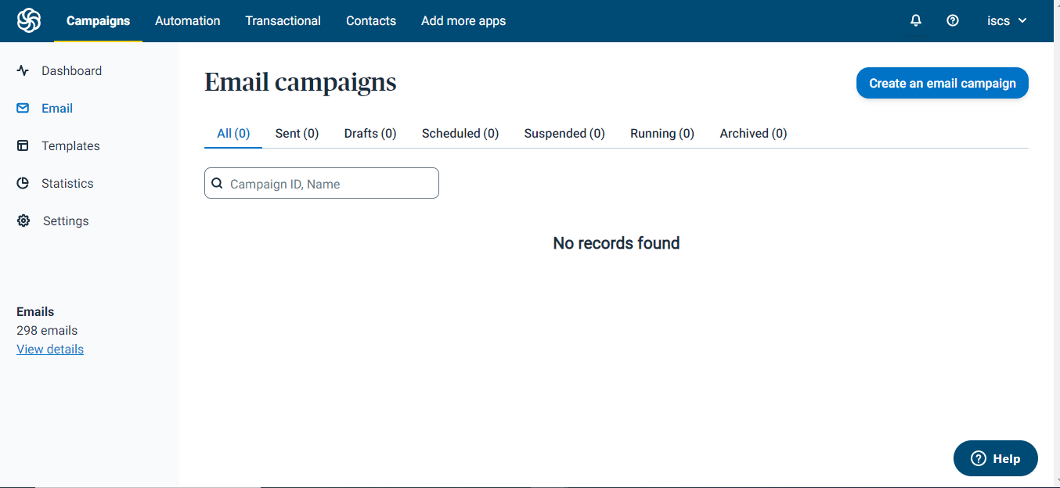

1. Next click on iscs we can see below page

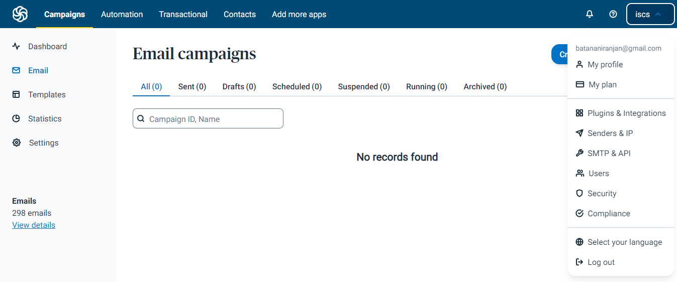

4.Click on SMTP & API

As 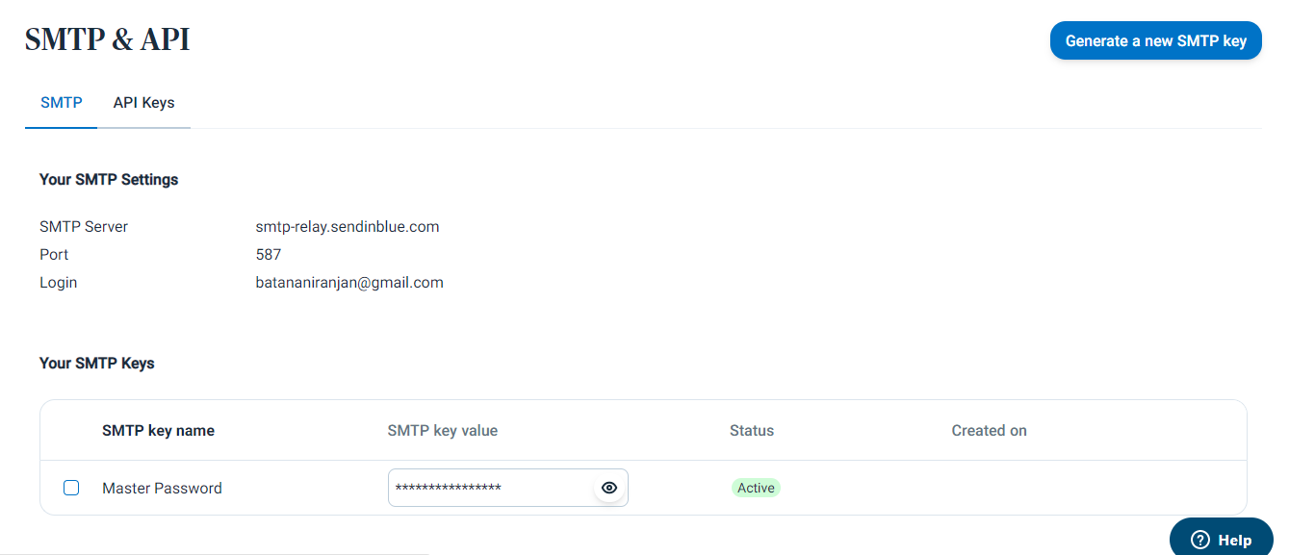

5.Take host,port and user id and password from the server .

Place SENDSMTP activity on your studio as below

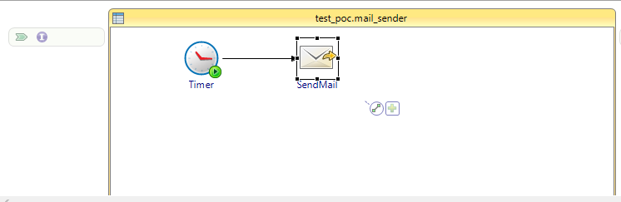

Next go to general tab on the send mail activity

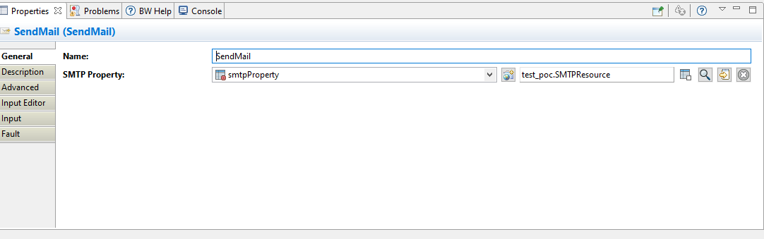

6.next go to resource file configured in send mail activity and give the credentials what ever we taken from the smtp server as below

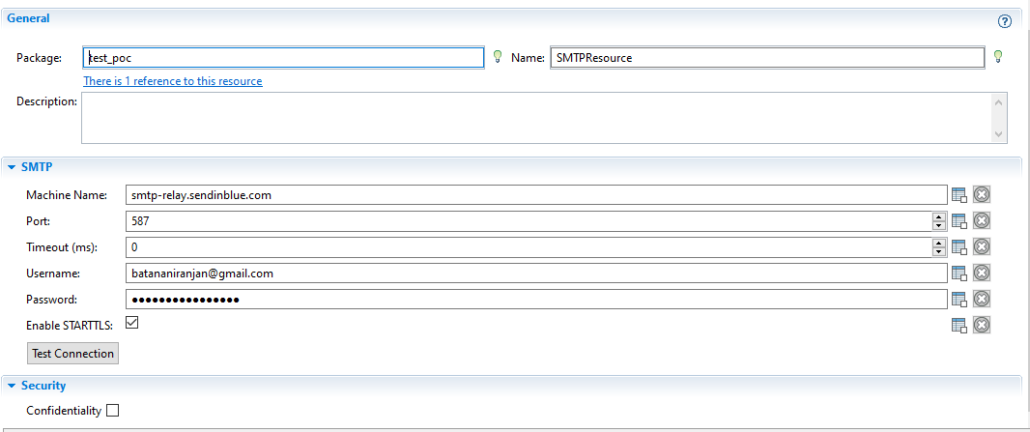

7.Give the the from email id and to email id in input tab and give the inputs as per our requirements in input tab

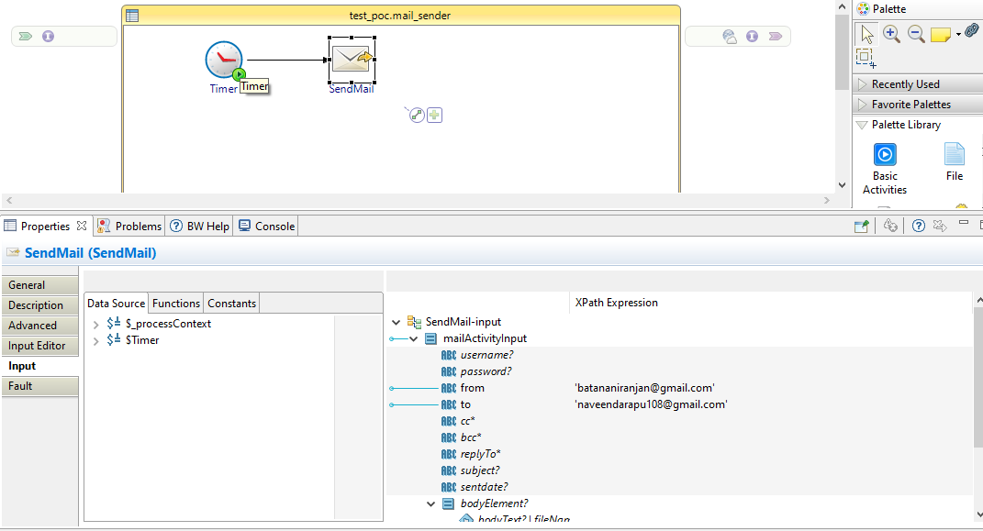

8.Do debug automatically mails will send to sender mail

Note :- check mails in spam if in case mail is to their in inbox.